JAGADHA BY PADANJALY
Sales Analysis Report

1. Executive Summary
This report combines four pieces of work on Jagadha by Padanjali Ayurvedic Private Limited (Padanjaly): the company profile, the dataset review, the data-cleaning process and the final exploratory sales dashboard built in Power BI. The dataset holds 690 WooCommerce orders placed between January 2023 and May 2026.
Converted to rupees, sales come to about ₹2.5 million: ₹1.35M from INR orders plus $13.45K from USD orders. Five findings stand out: Agnijith earns about half of all product sales (about 87% with its pack sizes); many customers buy multi-jar treatment courses; sales peak in April to July and again in October; almost every order is paid through Razorpay; and 41% of orders are still marked “processing”. Each finding below is followed by the likely reason and a recommended action.

2. Company Background
- Who they are: an Ayurvedic provider established in December 1995, specialising in burns, scars (keloids and hypertrophic scars), non-healing wounds and selected skin and hair concerns. Clinical centres are at Ernakulam and Kuttippuram; manufacturing is at Malamakkavu, Palakkad.
- How they sell: hospital OP and IP care, remote consultation by WhatsApp or email with wound photos, home delivery of medicines, product sales, and reported retail distribution in Dubai, Sharjah and Ajman through Kely Herbal Botanicals.
- Products (listed prices): Agnijith (flagship, ₹2,100 for 90 g, packs up to 10), Agnihari (₹510), Kasmeerini face oil (₹340) and Kadambini scalp oil (₹280). The website offers no discounts or coupons and collects no tax.
- Note: testing, recognition, licence and leadership claims come from the company presentation and are not independently verified, so they are treated here as background only.

3. Dataset and Data Preparation
The dataset has 690 rows (one per order) and 72 columns covering orders, payments, customers, locations and up to two products per order; product items 3 and 4 are empty. The raw data was kept unchanged and all cleaning was done on a separate copy in Power Query, so every step can be repeated.
- Types and dates: data types corrected; order and paid date-times split into separate date and time columns.
- Currency: the data mixes USD and INR, so each USD order was converted to rupees at the exchange rate of its order date.
- Products: the packed line-item text was split into name, SKU, quantity and total columns, and special codes were decoded.
- Locations: billing and shipping city, state and country were checked against postcodes and saved in new verified columns.
- Nulls and zeros kept: a blank paid date means unpaid; blank item 2 means a single-product order; zero tax and discount columns confirm no tax and no discounts.
- Customers: guest orders (customer_id = 0) were flagged with a customer_type column, and 2 duplicates were removed.

4. Exploratory Sales Dashboard
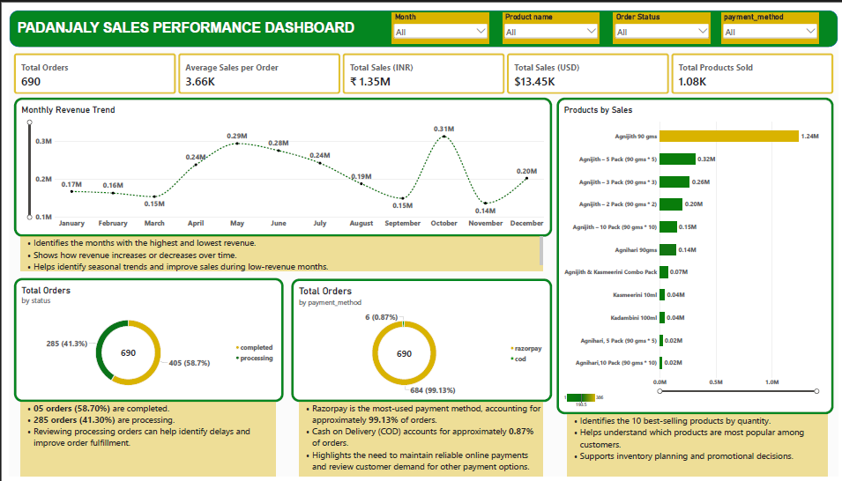
Figure 1: Padanjaly Sales Performance Dashboard (Power BI)
The dashboard has four slicers (Month, Product name, Order Status and payment_method), five KPI cards and four visuals: a monthly revenue line chart, a Products by Sales bar chart showing 11 products, and two donut charts for order status and payment method. Each visual has a short explanatory note beneath it.
KPI | Value | What it tells us
Total Orders | 690 | Distinct orders from Jan 2023 to May 2026, about 17 a month.
Total Sales (INR orders) | ₹1.35M | Sales from orders placed in rupees.
Total Sales (USD orders) | $13.45K | Roughly ₹1.2M when converted, so overseas orders are close to half of sales.*
Average Sales per Order | ₹3.66K | A typical order is small: one or two items.
Total Products Sold | 1.08K | About 1.6 units per order; most baskets hold a single product.
*Estimate: the twelve monthly bars sum to about ₹2.52M and 690 × ₹3.66K is about ₹2.53M, which matches ₹1.35M plus $13.45K at roughly ₹87 per dollar. Please confirm with a converted-total card in Power BI.

5. Insights and Reasons

5.1 Agnijith drives about half of all sales
- Insight: Agnijith 90 g alone earns ₹1.24M of the ₹2.50M across the 11 products in the chart (50%). With its 2, 3, 5 and 10-packs the Agnijith range reaches ₹2.17M, about 87%. Agnihari (all pack sizes, ₹0.18M) adds 7%, the Agnijith and Kasmeerini combo pack 3%, and Kasmeerini and Kadambini 2% each.
- Why it happens: Agnijith is the flagship for burns and scars, the clinic’s core specialty, and doctors prescribe it during remote consultations. It also costs four to seven times more than the other products, so each order is worth more.

5.2 Customers buy treatment courses, not single jars
- Insight: The 2, 3 and 5-packs bring ₹0.78M, about 31% of product sales; adding the 10-pack (₹0.15M) takes multi-jar packs to ₹0.93M, about 37%.
- Why it happens: Scar and burn recovery takes months of regular use, and patients who live far away order several jars together to avoid repeat shipping. The saving is small: at listed prices the 2 and 3-packs have no discount and the 5 and 10-packs save only about 3%. Buying is driven by need, not by price offers.

5.3 Sales are seasonal, with a sharp October peak
- Insight: October is the highest month (₹0.31M), followed by May (₹0.29M) and June (₹0.28M). The lowest are November (₹0.14M), March and September (₹0.15M each). November falls about 55% below October.
- Why it happens: April to July is the school-holiday and summer period, a convenient time to begin scar treatment. The October spike followed by a steep drop looks like a one-off event, such as a festive push, a bulk or overseas order, or media attention, rather than a steady pattern. Note that the chart adds each month across years: January to May include 2026 (four years) while June to December have three.

5.4 Almost all customers pay online through Razorpay
- Insight: Razorpay handles 684 orders (99.13%); cash on delivery has only 6 (0.87%).
- Why it happens: Many customers order after a remote consultation and are not buying in person, and cash on delivery usually does not work for overseas orders. The higher-priced products also suit prepaid payment.

5.5 41% of orders are still “processing”
- Insight: 405 orders (58.7%) are completed and 285 (41.3%) are processing.
- Why it happens: Over a period of more than three years, hundreds of orders are unlikely to be genuinely pending. Most likely the status is not changed to Completed after dispatch or delivery, since WooCommerce keeps paid orders in Processing until someone updates them.

5.6 Overseas orders are a large share of revenue
- Insight: USD orders ($13.45K, roughly ₹1.2M) are close to 46% of estimated total sales.
- Why it happens: Remote consultation by WhatsApp or email and the website let overseas patients buy without visiting Kerala, and Agnijith is compact and easy to ship. The UAE retail sales are outside this dataset.

6. Conclusion
The cleaned dataset and Power BI dashboard show a business built around one flagship product, sold as long-term courses through a mainly online, partly overseas channel. Revenue is seasonal, payments are almost entirely digital, and the order-status field needs attention. Acting on the recommendations above can reduce dependence on Agnijith, smooth the slow months and make order tracking reliable. Figures marked as estimates should be confirmed against the final Power BI visuals.

References
Padanjali Ayurvedic (P) Ltd. (n.d.). About. Retrieved 15 October 2026, from https://www.padanjaly.com/about-us/
Padanjali Ayurvedic (P) Ltd. (n.d.). Home page. Retrieved 15 October 2026, from https://www.padanjaly.com/
Jagadha by Padanjaly WooCommerce orders dataset (690 orders, January 2023 to May 2026) and the Padanjaly Sales Performance Dashboard (Power BI).

